**Shell Script Assignment**

1. **Create a script named “myscript” in current directory to do the following.**
2. **display “hello user”**
3. **list files in current directory**
4. **name of logged in user**
5. **date**

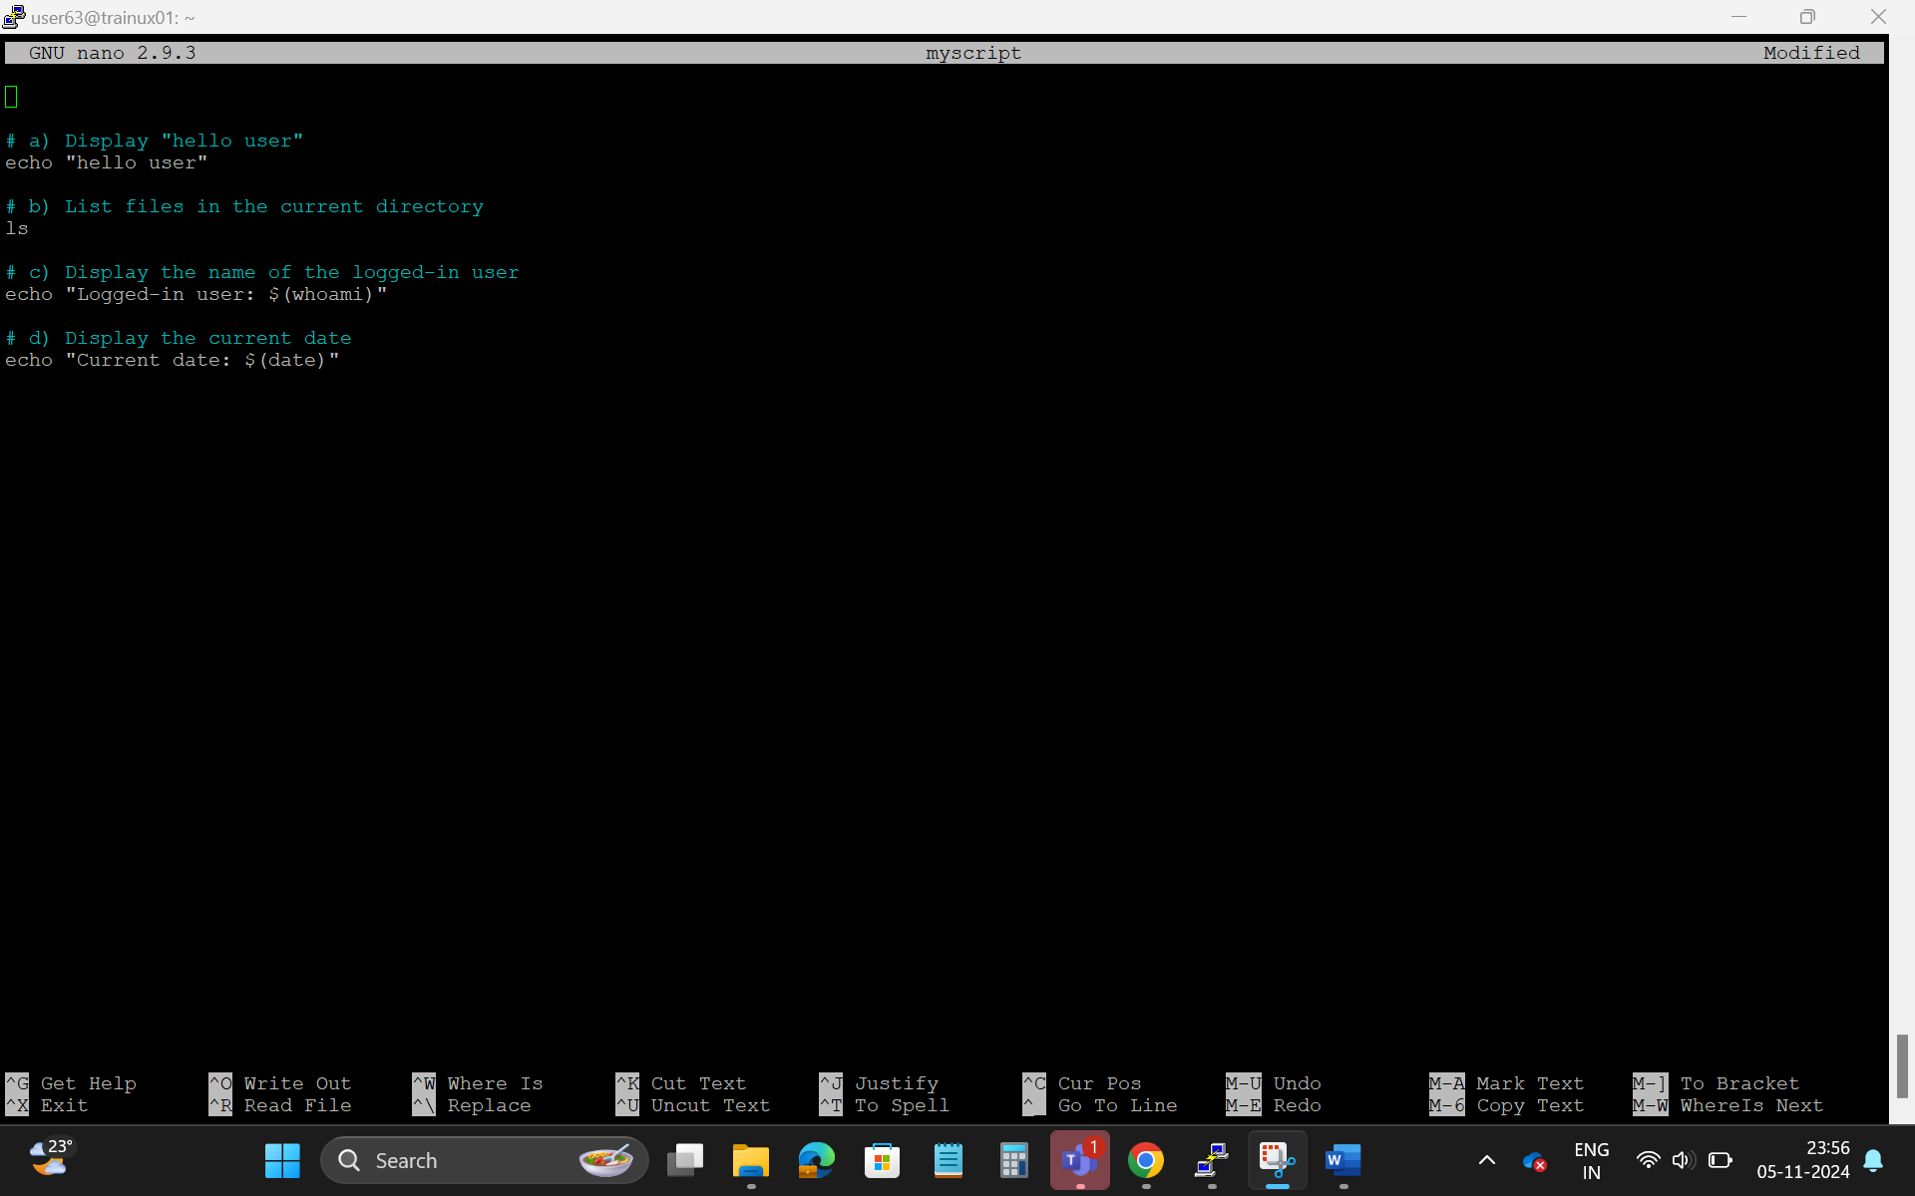

1. **Add execute permission and Run the script from**
2. **current directory**

chmod +x myscript

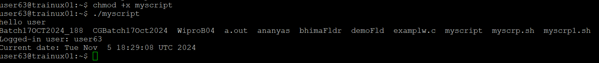./myscript

1. **Create a subdirectory named “test”**

mkdir test